|  |  |
| --- | --- |
|  |  |
| *Optical Mark Recognition* |  |
|  |  |
|  | May 11, 2021Ahmed Ahmed ElrewaidyAhmed nabil lotfyEslam Khalid ElfauomyAkram Hesham RagabBasma Mohamed Ahmed |

### TABLE OF CONTENT:

* Problem challenges
* model sheets offered

# Problem challenges:

Unfortunately, the challenges of an image processing task are usually higher, more difficult than a traditional software program because unlike the traditional programs, the computer is actually trying to understand something!

We can present some of these challenges in the following bullet points.

* **Resolution problem**: there are too many things that can affect the resolution of an image. Lighting or different camera mobile or the angel where you took the image are all a disadvantage in those systems because they can dramatically destroy the accuracy. And the reason for this is that the values of pixels change every time.
* **Too many hyperparameters to tune (we will discuss this in a greater detail later)**: every time you do for example an edge detection task, you need to give the function some parameters with your choice, if those values are slightly not accurate, they can miss up the whole thing!
* **Overfitting the model you are working on**: for any machine learning or deep learning engineer or even a data scientist, it’s very obvious that the main problem of all time is the ability of your model to generalize, can a system that has the ability to recognize cars also recognize trucks? Can the model that corrects the answers for 100 problem corrects more, like say 150 or 200 or further. The answer is usually no because that is not the way that machines think yet, and to be honest **that’s a really hard problem**. But the research is also going too fast toward this direction, researches are trying to invent stronger types of neural networks to be able to mimic precisely how human can generalize.
* **Too many questions**: that means even smaller shapes to deal with which makes the problem even harder

# model sheets offered:

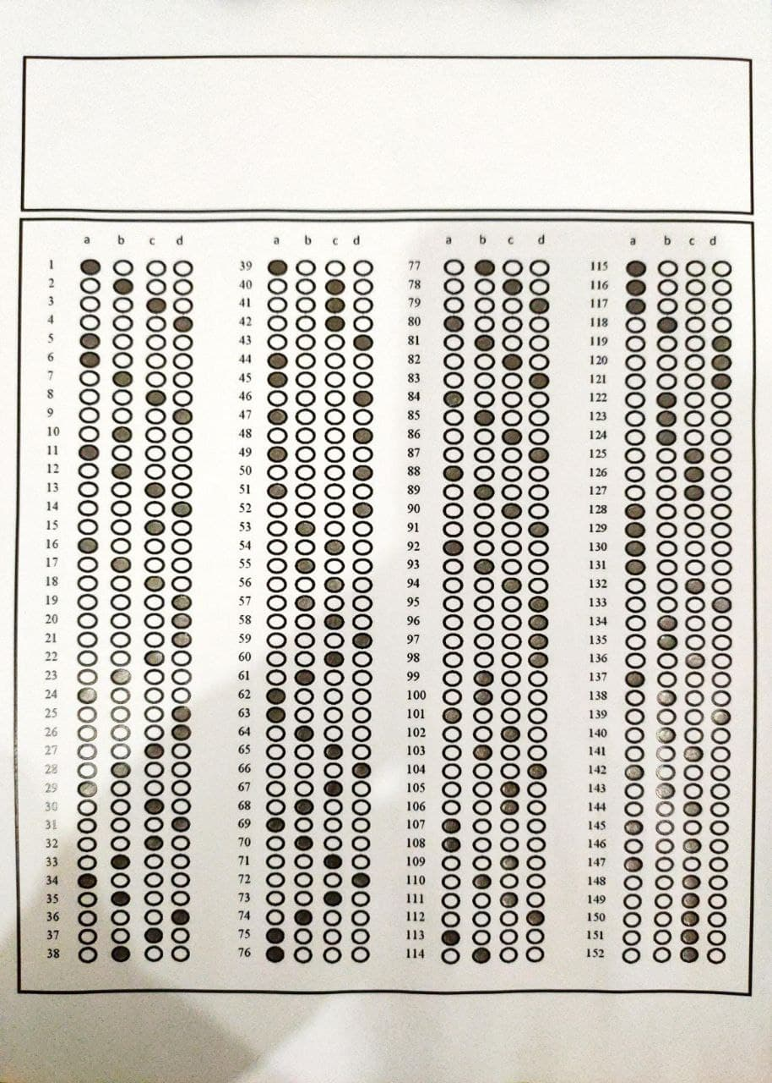

Fig1 152 question sheet

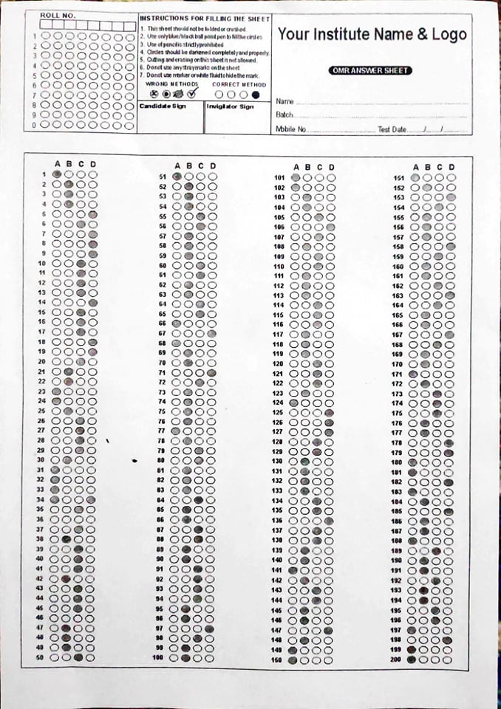

Fig 2 200 question sheet

Later we will discuss the difference between two models and why the 150 questions model is less prone to low accuracy, or why it’s more reliable and holding many advantages.